## Basics

* operating system
* free
* open source

### parked topics:-

internal working of command

### History

Ken Thompson 1970s UNIX

MULTICS

UNICS

Unix

GE to AT&T

PDP 7

Dennis Ritchie C

Brian Kernigham

Linus Torvalds 1990s Linux

Richard Stallman open source

### open source

1. sell the ice cream, recipe private
2. sell the ice cream, recipe public
3. ice cream free, recipe private
4. ice cream free, recipe public

source code open

firefox

VLC

GIMP

Blender

Audacity

Wordpress

Linux

### standards

sys V

BSD

### Unix based

BSD Unix →

Next

Darwin

Solaris

AIX

HP-UX

Xenix

Free BSD

### Linux based

Red Hat

BOSS

Mint

Fedora Core

OpenSuse

Debian Linux

Ubuntu

Kali Linux

kernel

## Linux Architecture



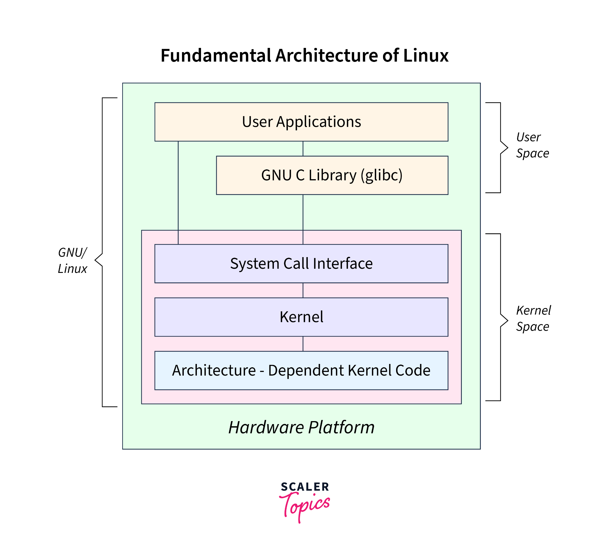

### Hardware layer

* CPU
* memory
* storage
* peripherals

### kernel layer

* process management
* memory management
* file system management
* device drivers
* network stack

### system call interface

system calls

* file operations
* process control
* IPC
* networking

### user space

#### system libraries

GNU C (glibc)

#### utilities

### shell

### user applications

* web browser
* text editors
* development tools

### File architecture

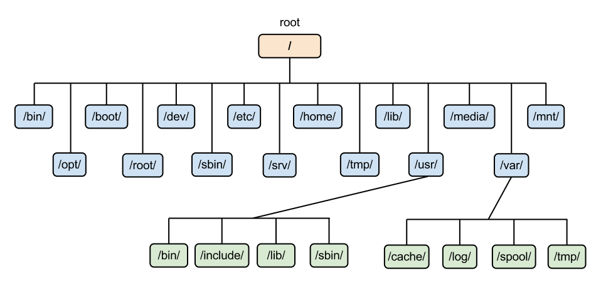

inverted tree structure

/

/home/john

/root

### init subsystem

pid 1

sysV init

traditional

/etc/inittab

/sbin/init

systemd

/etc/systemd/system

/lib/systemd/system

systemctl

### linux runlevels

0 halt the system

1 single user mode

2 multi user mode (without networking)

3 full multi-user mode with networking

4 user-defined

5 multi user mode with GUI

6 reboot the system

### boot - quick overview

BIOS/UEFI

initialise hardware

selects boot device

Bootloader (GRUB, LILO)

loads the kernel into memory

kernel initialization

hardware

mount

init/systemd

runlevel/target

login shell

## Shell

* command line interface
* cli (command line interpreter)
* terminal

sh

ksh

csh

tcsh

zsh

Fish

bash

### tcsh

csh (UNIX C shell)

tcsh

### prompt

username@hostname folder

$ normal user

>

# root

### command

command options arguments

command arguments options

* fundamental unit
* code
* executable
* spawn a new process

### builtin

* executed by shell itself
* not a new process
* (not fetching the code from somewhere else)

cd, echo, export, alias, type, history pwd

### environment variables

SHELL

LOGNAME

PATH

MANPATH

## commands

### Basic commands

ls

-a

-l

-i

-h

cd

change directory

cd Videos

.. parent

cal

-y

date

clear

bc

pwd

print working directly

### misc commands

whoami

echo $SHELL

who

touch

alias

unalias

hostname

history

shutdown

uname

whereis

which

### find

-type

f

d

-perm

-exec

-name

-iname

### pipes |

* connection mechanisms
* chaining

## help

whatis

- - help

apropos

### man

q

/text search “text”

n

shift+n

### man pages

1. general commands (ls, cp)
2. system calls (eg open, getpid)
3. library functions (eg printf, malloc)
4. special files (usually found in /dev)
5. file formats & conventions
6. games, screensavers
7. miscellaneous

protocols

signals

conventions

1. system administration commands

## Files & Directories

### files

* basic unit of data storage
* text files

.py

.c

.c++

.sh

* binary files

### editors

gedit

vi (vim)

nano

atom

sublimetext

vscode

emacs

notepad++

### view

cat

nl

less

more

head

tail

most

### other commands

cp

copy

mv

move (cut & paste)

rename

rm

remove (delete) file/directory

-i interactive

-f force

-r recursive

wc

-l

-c

-w

### directories

* relative paths
* absolute path
* home directory for every user

cd

<dir>

.. parent

. current directory

~ home directory

mkdir

make directory

rmdir

remove a directory

only empty directory

### inode

* unique identifier for every file in the storage

ls -i

### file descriptor

* temporary number
* lowest possible number

stdin 0

stdout 1

stderr 2

hello.txt 3

./a.out

0 → pts/0

1 → pts/0

2 → pts/0

3 → hello.txt

### types of files

regular files

-

directory

d

symbolic links

l

character device files

c

block device files

b

named pipes (fifos)

p

sockets

s

## vi

vim

insertion mode

i

command mode

esc

### commands

:w save (write)

:w! save as

:q! quit without saving

:wq save & quit

dd cut

delete

3dd cut 3 lines

p paste

yy copying

u undo

ctrl+r redo

### redirection

>

>> append

## user & groups

* home directory for every user
* uid
* gid

yearly_trainings.data

| permissions | | |
| --- | --- | --- |
| user | group | others |
| john | training | others |
| read write ~~execute~~ | read write ~~execute~~ | read ~~write execute~~ |
|  |  |  |

### superuser

root #

### modes

| user | group | others |
| --- | --- | --- |
| r w - | r w - | r - - |
| 1 1 0 | 1 1 0 | 1 0 0 |
| 6 | 6 | 4 |
| u | g | o |

filea.txt 664

666

chmod +w

chmod o+w

chmod 0666 filea.txt

### commands

chmod

chown

chgrp

useradd

passwd

groupadd

usermod

-G groupname

groups

groups username

id username

## scripting

.rc

configuration files

resource control

(run commands)

shell scripts

#!

#!/bin/python3

echo

read

### special variables

$$

$?

$#

$0

$1

…

…

$n

### math

let

expr

(( ))

### conditionals

if

case

for

while

until

### operators

arithmetic

+ - * / %

=

==

!=

#### relational

-eq

-ne

-gt

-lt

-ge

-le

#### string

=

!=

-z zero length

#### file

[ -f $filename ]

-f $filename if it’s a file

-r $filename if it has read permissions

### while

## wild cards

* any number of characters

zero or more

? single character

[ ] single character

can be chosen from multiple options

range

## grep

* finds a pattern
* n
* i
* v

find → names(paths) of files

grep → “pattern” in the name (path) of the file

### xargs

find ~/Desktop/liftoff/ -type f -mtime -1 | xargs grep -i "ringo"

### regex

metacharacters

^ start of the line

$ end of the line

. one character placeholder

* zero or more occurrences

[ ] multiple options

range of options

#### extended regex

? zero or one occurrences

+ one or more occurrences

| alternation

( ) grouping

{ } repetition

## links

1. hard links
2. symbolic (soft) links

## tar and zip

tar Tape ARchive

ZIP

tar.gz

.tgz (tar file with gzip compression)

tar.bz2 (tar file with bzip compression)

tar cf file.tar.gz

tar xf file.tar.bz2 -C directory_name

unzip file.zip -d directory_name

gunzip file.gz

## storage & memory

ls -lh

df

disk free

df -h

df –total

## process

ps

-A all process in the system

-a hidden process in the shell 9all)

aux all process, different set of columns

-e all process

-f full-format listing

-ef all process, different set of columns

-ax all process, different set of columns

-C search for a process by name

-o customising the output columns

kill

### info

%CPU

blocked signals

process state

username , uid

gid

system at launch

CPU time

running since (elapsed time)

number of threads

id of threads

pid (process id)

ppid (parent process id)

RSS

VIRT/VISZ

%memory

priority

TTY

file descriptors

-o

pid process id

ppid parent pid

tty terminal ids

time the actual “critical” time taken by the process

stime system time when it was launched

etime overall elapsed time

cmd the command or executable used to launch

pri priority of the process

user user name who launched the process

stat state of the process

lwp thread ids

nlwp number of threads

### state

run r actively using the CPU

sleep(wait) S waiting for an event to happen]

waiting for a timer to getover

stop T paused & sent to the background

kernel I kerned based processes

D

Z zombie state

orphan

child → parent

zombie (defunct)

### signal

| **signal** | **keyboard ?** | **ignored?** |  | **default action** |
| --- | --- | --- | --- | --- |
| SIGTERM | no | yes | 15 | terminates the process |
| SIGINT | ctrl+C | yes | 2 | terminates the process |
| SIGKILL | no | no | 9 | terminates the process |
| SIGSTOP | ctrl + Z | no |  | put it in “stop” state |
| SIGCONT | no | yes |  | continue a process |
| SIGFPE |  | yes |  | terminate |
| SIGSEGV |  | yes |  | terminate |

default SIGTERM

kill -9 pid

### background

1. background of system

daemon

1. background of the shell

### jobs

fg

### other commands

pidof

pkill

stark_arya

stark_sansa

stark_bran

snow_jon

stark_tony

stark_robb

pkill stark

### nice

-19 to 20

prlimit

htop

iptraf

watch

### /proc

procfs

## network

internet

MAC

48 bit

ethernet

hardware address

globally unique

IP address

logical address

32 bit

IPv4

223.230.40.188

IPv6

128 bit

fe80::

127.0.0.1

localhost

DNS

hostnames to IP address

[www.qualcomm.com](http://www.qualcomm.com) → 234.67…..

ping

packet internet groper

### remote connections

FTP

telnet

SSH

RDP

HTTP

### SSH

ssh remote_usrename@IP addr

client ← → server

10.0.0.157

scp

## all commands

pwd

ls

cal

bc

date

whatis

man

apropos

clear

mkdir

rmdir

cd

cp

mv

rm

cat

head

tail

more

most

less

nl

su

who

whoami

useradd

groupadd

passwd

usermod

chmod

chown

chgrp

id

groups

touch

alias

unalias

hostname

history

shutdown

uname